

# Batch: B-2 Roll No.: 16010422234 Experiment No.: 4

**____________________________________________________________________________________**

**Aim:** Write PHP programs to demonstrate working of cookies and session handling with the help of basic programming constructs.

**____________________________________________________________________________________**

**Resources needed:** Windows OS, Web Browser, Editor, XAMPP Server

**____________________________________________________________________________________**

# Pre Lab/ Prior Concepts:

Students should have prior knowledge of HTML/CSS/Basic Programming.

**____________________________________________________________________________________**

# Theory:

# **Cookie:**

A cookie is often used to identify a user. A cookie is a small file that the server embeds on the user's computer. Each time the same computer requests a page with a browser, it sends the cookie too with the request.

**In PHP, to create/modify/delete a cookie, the setcookie() function is used**.

The syntax of setcookie() function is as follows:

***setcookie (name, value, expire, path, domain, secure, httponly)***

Where

**name** - The name of the cookie.

**value** - The value of the cookie. This value is stored on the clients computer; do not store sensitive information.

**expire** - The time the cookie expires. This is a Unix timestamp so is in number of seconds since the epoch. In other words, you'll most likely set this with the time() function plus the number of seconds before you want it to expire.

**path** - The path on the server in which the cookie will be available on. If set to '/', the cookie will be available within the entire domain. If set to '/foo/', the cookie will only be available within the /foo/ directory and all sub-directories such as /foo/bar/ of domain. The default value is the current directory that the cookie is being set in.

**domain -** The (sub)domain that the cookie is available to. Setting this to a subdomain (such as 'www.example.com') will make the cookie available to that subdomain and all other sub-domains of it (i.e. w2.www.example.com). To make the cookie available to the whole domain (including all subdomains of it), simply set the value to the domain name ('example.com', in this case).

**secure-** Indicates that the cookie should only be transmitted over a secure HTTPS connection from the client. When set to TRUE, the cookie will only be set if a secure connection exists.

**httponly -** When TRUE the cookie will be made accessible only through the HTTP protocol. This means that the cookie won't be accessible by scripting languages, such as JavaScript.

# To retrieve a cookie value $_COOKIE superglobal is used.

*For example:* Assuming the cookie name is 'favcolor', this value is retrieved using $_COOKIE['favcolor']

**Session Handling:**

HTTP is a stateless protocol. So the web server treats every request as a new request. So session variables solve this problem by storing user information to be used across multiple pages. By default, session variables last until the client closes the browser.

* Unlike a cookie, the information is not stored on the client’s machine.

The working of a session can be understood with the help of the below diagram:

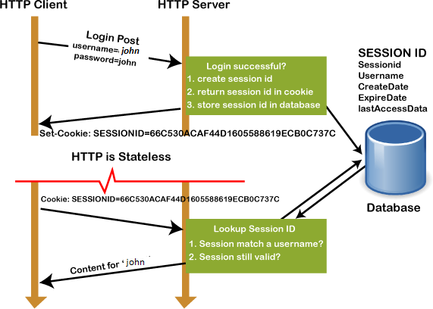Session vs. Cookies

**To create a session / resume a session ,session_start() function is used.** session_start() creates a session or resumes the current one based on a session identifier passed via a GET or POST request, or passed via a cookie.

# To set/modify/retrieve a session variable value, $_SESSION superglobal is used.

*For example:* Assuming the session variable name is 'favcolor',

* It's value is set as $_SESSION['favcolor'] =’green’
* It’s value is modified as $_SESSION[‘favcolor’] = ‘blue’
* It’s value is retrieved as $_SESSION[‘favcolor’

**____________________________________________________________________________________**

# Procedure:

1. Read reference[1] to know more about cookies and sessions.
2. Write a simple program to set a cookie, and then read back the value.
3. Write a code to delete the cookie.
4. Start a session and check for timeout.
5. Delete the session.
6. Paste the code and output snapshots in the write-ups and submit.

**____________________________________________________________________________________**

# Output: (Code with result Snapshot)

**<!DOCTYPE html>**

**<html lang="en">**

**<head>**

**<meta charset="UTF-8">**

**<meta name="viewport" content="width=device-width, initial-scale=1.0">**

**<title>Perfume Paradise</title>**

**<style>**

**body {**

**font-family: 'Segoe UI', Tahoma, Geneva, Verdana, sans-serif;**

**background-color: #fefefe;**

**margin: 0;**

**padding: 20px;**

**}**

**.container {**

**width: 50%;**

**margin: auto;**

**background: #f8f8ff;**

**padding: 30px;**

**box-shadow: 0px 0px 20px rgba(0, 0, 0, 0.1);**

**border-radius: 15px;**

**}**

**.header {**

**text-align: center;**

**padding: 15px;**

**background: #ffe4e1;**

**color: #5f6368;**

**border-radius: 10px;**

**font-size: 24px;**

**font-weight: bold;**

**letter-spacing: 2px;**

**}**

**.message {**

**text-align: center;**

**margin: 25px 0;**

**font-size: 20px;**

**color: #6a5acd;**

**}**

**.product {**

**text-align: center;**

**padding: 20px;**

**background: #e6e6fa;**

**border-radius: 10px;**

**font-size: 18px;**

**color: #483d8b;**

**}**

**</style>**

**</head>**

**<body>**

**<div class="container">**

**<div class="header">**

**<h1>Welcome to Perfume Paradise</h1>**

**</div>**

**<?php**

**setcookie("fav_perfume", "Aqua Di Gio", time() + (86400 * 30), "/");**

**if(!isset($_COOKIE["fav_perfume"])) {**

**echo "<div class='message'>Welcome! We have set your favorite perfume to Aqua Di Gio.</div>";**

**} else {**

**echo "<div class='message'>Welcome back! Your favorite perfume is " . $_COOKIE["fav_perfume"] . ".</div>";**

**}**

**?>**

**</div>**

**</body>**

**</html>**

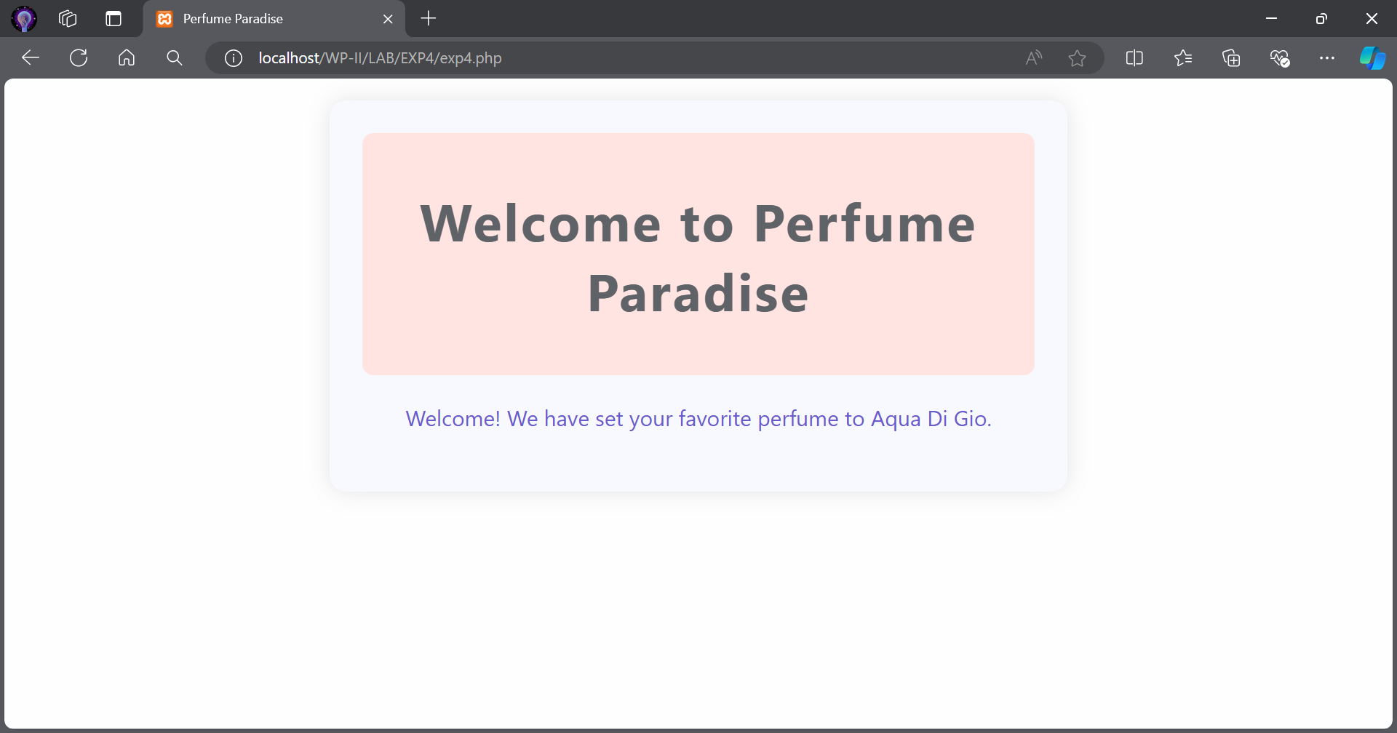

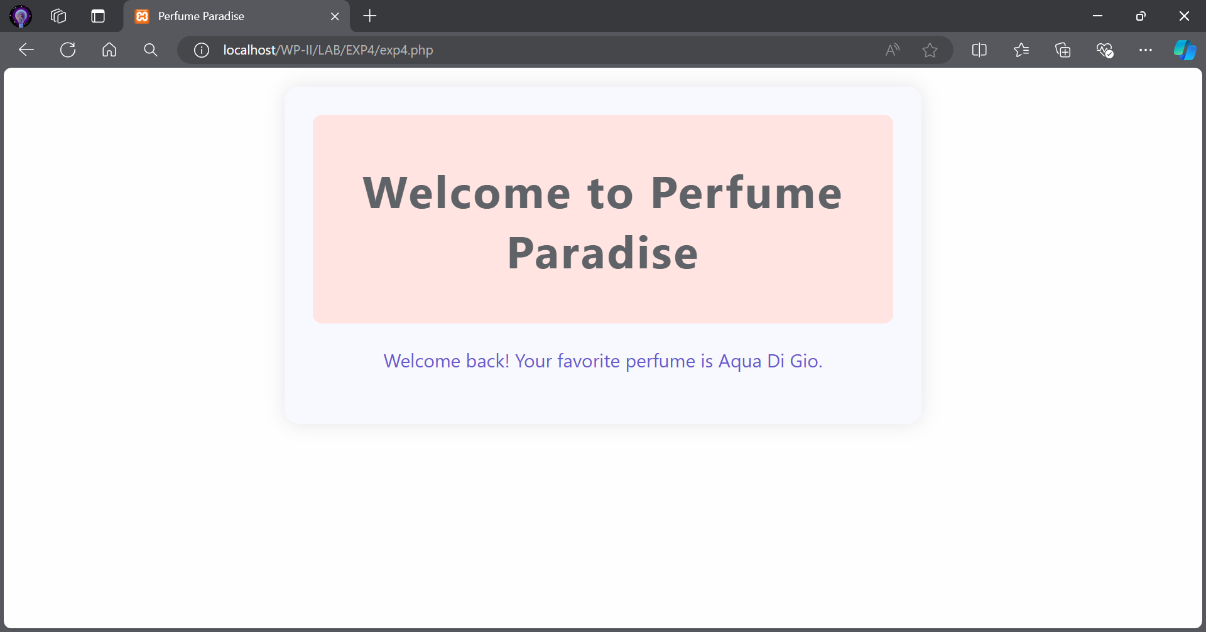

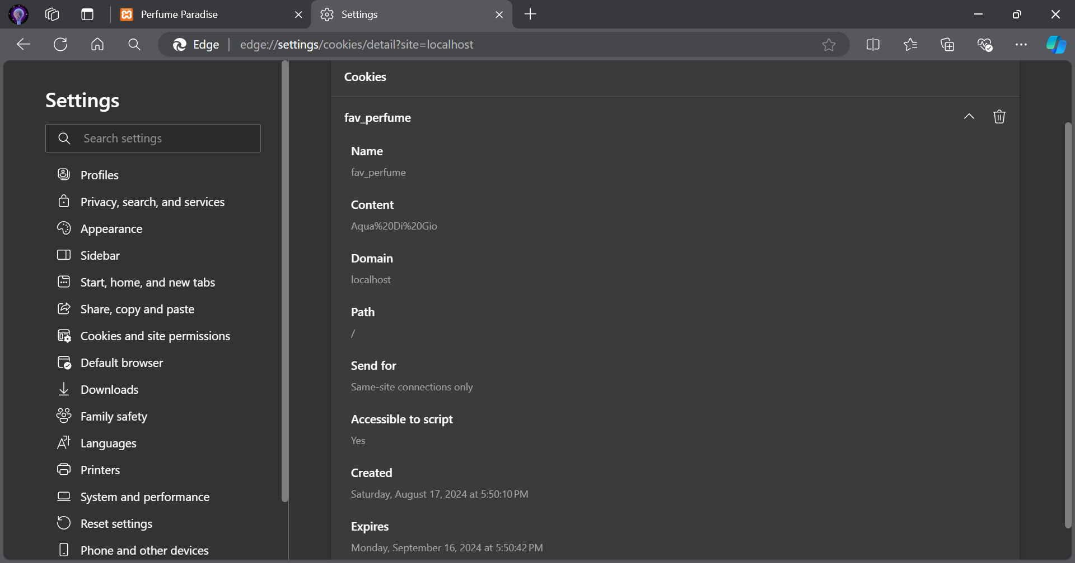

**<!DOCTYPE html>**

**<html lang="en">**

**<head>**

**<meta charset="UTF-8">**

**<meta name="viewport" content="width=device-width, initial-scale=1.0">**

**<title>Delete Cookie - Perfume Paradise</title>**

**<style>**

**body {**

**font-family: 'Segoe UI', Tahoma, Geneva, Verdana, sans-serif;**

**background-color: #fefefe;**

**margin: 0;**

**padding: 20px;**

**}**

**.container {**

**width: 50%;**

**margin: auto;**

**background: #f8f8ff;**

**padding: 30px;**

**box-shadow: 0px 0px 20px rgba(0, 0, 0, 0.1);**

**border-radius: 15px;**

**}**

**.header {**

**text-align: center;**

**padding: 15px;**

**background: #ffe4e1;**

**color: #5f6368;**

**border-radius: 10px;**

**font-size: 24px;**

**font-weight: bold;**

**letter-spacing: 2px;**

**}**

**.message {**

**text-align: center;**

**margin: 25px 0;**

**font-size: 20px;**

**color: #6a5acd;**

**}**

**</style>**

**</head>**

**<body>**

**<div class="container">**

**<div class="header">**

**<h1>Goodbye from Perfume Paradise</h1>**

**</div>**

**<?php**

**setcookie("fav_perfume", "", time() - 3600, "/");**

**echo "<div class='message'>Your favorite perfume cookie has been deleted.</div>";**

**?>**

**</div>**

**</body>**

**</html>**

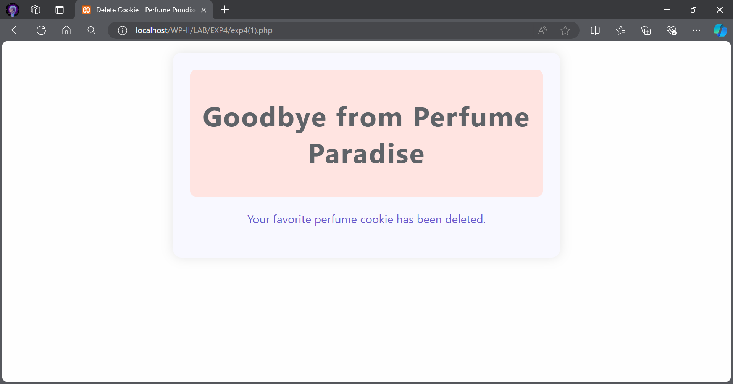

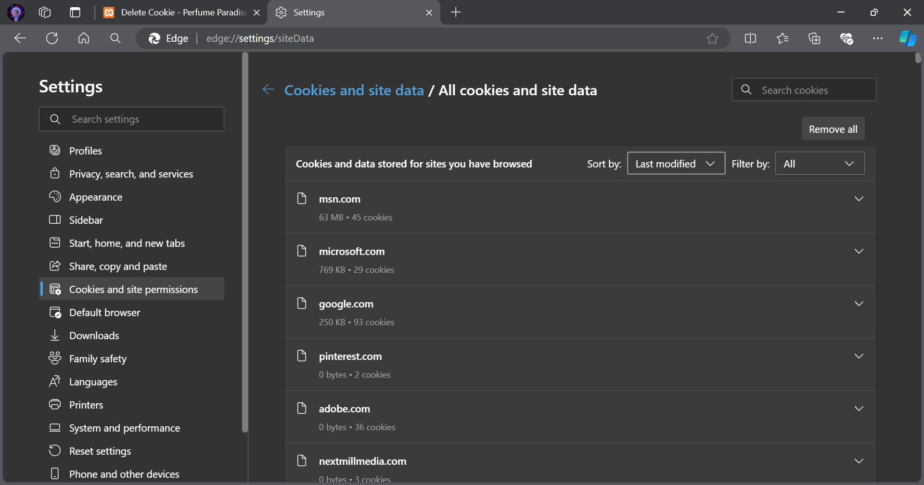

**<!DOCTYPE html>**

**<html lang="en">**

**<head>**

**<meta charset="UTF-8">**

**<meta name="viewport" content="width=device-width, initial-scale=1.0">**

**<title>Perfume Store - Session Handling</title>**

**<style>**

**body {**

**font-family: 'Segoe UI', Tahoma, Geneva, Verdana, sans-serif;**

**background-color: #E0F7FA;**

**margin: 0;**

**padding: 20px;**

**}**

**.container {**

**width: 50%;**

**margin: auto;**

**background: #F3E5F5;**

**padding: 30px;**

**box-shadow: 0px 0px 20px rgba(0, 0, 0, 0.1);**

**border-radius: 15px;**

**}**

**.header {**

**text-align: center;**

**padding: 15px;**

**background: #B3E5FC;**

**color: #37474F;**

**border-radius: 10px;**

**font-size: 24px;**

**font-weight: bold;**

**letter-spacing: 2px;**

**}**

**.message {**

**text-align: center;**

**margin: 25px 0;**

**font-size: 20px;**

**color: #5C6BC0;**

**}**

**</style>**

**</head>**

**<body>**

**<div class="container">**

**<div class="header">**

**<h1>Welcome to Perfume Paradise</h1>**

**</div>**

**<?php**

**session_start();**

**// Set a session variable for favorite perfume**

**if(!isset($_SESSION["fav_perfume"])) {**

**$_SESSION["fav_perfume"] = "Aqua Di Gio"; // default favorite perfume**

**echo "<div class='message'>Welcome! We have set your favorite perfume to " . $_SESSION["fav_perfume"] . ".</div>";**

**} else {**

**echo "<div class='message'>Welcome back! Your favorite perfume is " . $_SESSION["fav_perfume"] . ".</div>";**

**}**

**?>**

**</div>**

**</body>**

**</html>**

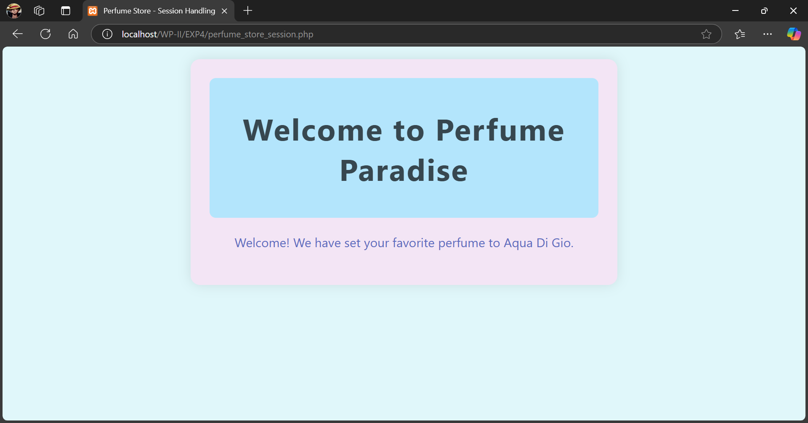

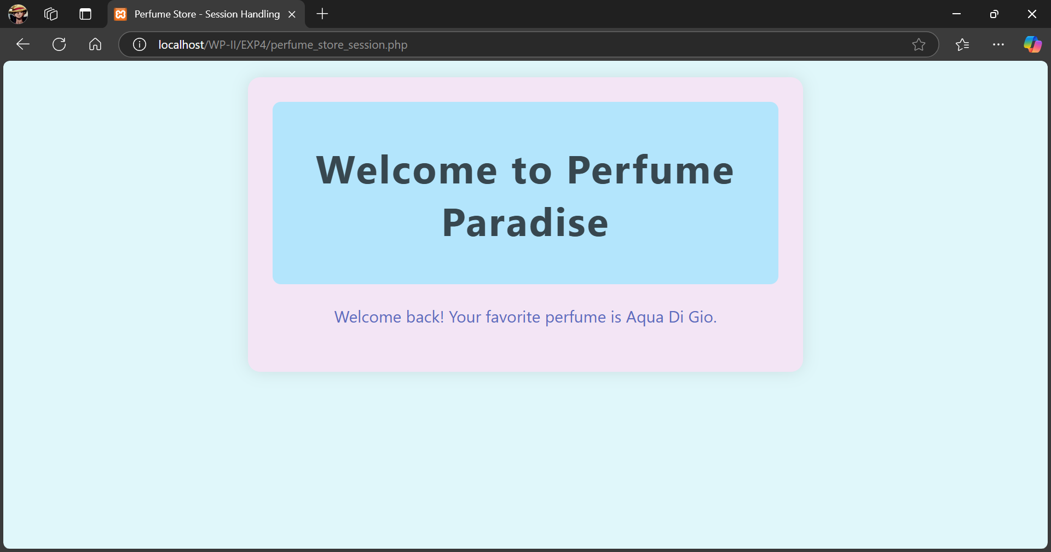

**<!DOCTYPE html>**

**<html lang="en">**

**<head>**

**<meta charset="UTF-8">**

**<meta name="viewport" content="width=device-width, initial-scale=1.0">**

**<title>End Session - Perfume Paradise</title>**

**<style>**

**body {**

**font-family: 'Segoe UI', Tahoma, Geneva, Verdana, sans-serif;**

**background-color: #E0F7FA;**

**margin: 0;**

**padding: 20px;**

**}**

**.container {**

**width: 50%;**

**margin: auto;**

**background: #F3E5F5;**

**padding: 30px;**

**box-shadow: 0px 0px 20px rgba(0, 0, 0, 0.1);**

**border-radius: 15px;**

**}**

**.header {**

**text-align: center;**

**padding: 15px;**

**background: #B3E5FC;**

**color: #37474F;**

**border-radius: 10px;**

**font-size: 24px;**

**font-weight: bold;**

**letter-spacing: 2px;**

**}**

**.message {**

**text-align: center;**

**margin: 25px 0;**

**font-size: 20px;**

**color: #5C6BC0;**

**}**

**</style>**

**</head>**

**<body>**

**<div class="container">**

**<div class="header">**

**<h1>Goodbye from Perfume Paradise</h1>**

**</div>**

**<?php**

**session_start();**

**// Remove a single session variable**

**unset($_SESSION["fav_perfume"]);**

**// Destroy the session completely**

**session_destroy();**

**echo "<div class='message'>Your session has ended, and favorite perfume preference has been cleared.</div>";**

**?>**

**</div>**

**</body>**

**</html>**

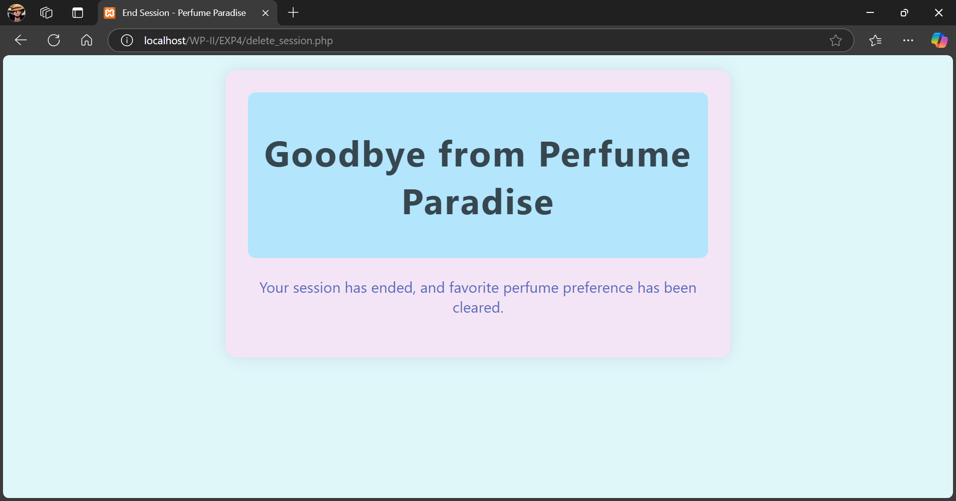

**____________________________________________________________________________________**

**Post Lab Questions:-**

1. **Explain the process of destroying a single session variable and the process of destroying the entire session with suitable examples of each.**

* To destroy a single session variable, you can use the unset() function. For example, unset($_SESSION['fav_perfume']); removes the session variable fav_perfume.
* To destroy the entire session, you first need to call session_unset() to free all session variables, followed by session_destroy() to completely destroy the session data stored on the server. This would make all session variables inaccessible.

1. **What are the different types of Cookies? What is the difference between them?**

* Session Cookies: These cookies are temporary and are erased when the browser is closed.
* Persistent Cookies: These cookies remain on the user's device until they expire or are deleted manually. They have a specific expiration date.
* Secure Cookies: These cookies are transmitted over secure HTTPS connections and help in ensuring the security of sensitive information.
* HttpOnly Cookies: These cookies are not accessible via JavaScript and can only be transmitted via HTTP/HTTPS requests, adding an extra layer of security against cross-site scripting (XSS) attacks.

1. **How website cookies can be made to comply with Data Privacy Regulations?**

* User Consent: Obtain explicit consent from users before storing cookies on their devices.
* Transparency: Clearly inform users about what data is being collected, how it will be used, and who it will be shared with.
* Cookie Policies: Implement a detailed cookie policy outlining the types of cookies used and their purposes.
* Secure Transmission: Ensure that cookies containing sensitive information are transmitted securely using HTTPS.
* Easy Opt-Out: Provide users with an easy way to opt-out of non-essential cookies.

**____________________________________________________________________________________**

**Outcomes: Design forms and use session handling mechanism with web applications**

**____________________________________________________________________________________**

**Conclusion: (Conclusion to be based on the objectives and outcomes achieved)**

In this experiment, I learned how to use cookies and session handling in PHP to manage user data and state across multiple web pages. Cookies are used to store user preferences and other information on the client-side, while sessions are used to maintain user-specific data on the server. This knowledge is essential for creating personalized and secure web applications, like an e-commerce website where user preferences and login states need to be preserved.

**____________________________________________________________________________________**

**Grade: AA / AB / BB / BC / CC / CD /DD**

**Signature of faculty in-charge with date**

**____________________________________________________________________________________**

**References:**

1. PHP Session & PHP Cookies with Example
2. Cookies and Sessions
3. Thomson PHP and MySQL Web Development Addison-Wesley Professional , 5th Edition 2016.

**____________________________________________________________________________________**